Environmental impact of dams

Table of Contents

Background 2
Introduction 2
Environment – the long term handicapped stakeholder 2
Hydropower – not so clean after all 3
“Lost” water 3
Seawater up the rivers 4
Dams trigger earthquakes? 4
Conclusion 5

Background

While it made irrigation possible in many places and provided cheap energy, the construction of large dams is one of the most costly and controversial forms of public infrastructure investment in developing countries, but little is known about their impact. By the end of the 20th century, the dam industry had “enriched” more than half of the earth's major rivers with approximately 50,000 large dams and now the consequences of people’s aspirations in controlling rivers are more and more subject to public criticism. With endless examples of failures in one way or another it is safe to conclude that the world's large dams have wiped out species, flooded huge areas of wetlands, forests and farmlands and displaced tens of millions of people.

Introduction

For over a century construction of dams has been regarded as the ultimate solution for sustainable development as it provides renewable energy, controls floods and stores water for irrigation year around. While keeping in mind the benefits of dams it is equally important to have a look at the downsides. We have been led to believe that the benefits out weight the negative impacts, but in many cases a lot of information was ignored or hid from public.
Many dam engineers are somewhat surprised by this recent, aggressive resistance, when in their honest opinion, the projects they develop are supposed to outweigh many times the negative effects - at least through the cheap, renewable energy provided and therefore the development of industries and economies as a whole. And indeed, all the beneficial effects of dams on development of societies cannot be ignored. There are many cases when dams prevented floods and this way saved lives, made it possible for industries to appear which leaded to development and multiplied the agricultural output, by supplying a constant amount of water of irrigation. Nevertheless, it is important to know the real price of the trade off, focusing not only on economic benefits but also the environmental impacts, which are hard to measure most of the times.

Environment – the long term handicapped stakeholder

When controlling the river flow, people might consider a lot of factors and undertake a lot of studies, but one large stakeholder was ignored most of time - the environment. And not surprisingly, it faces the most complex negative consequences.
Along with the water, dams hold back the river’s sediments, which end up clogging the reservoir. But the absence of these sediments downstream cause another series of problems like bank erosion due to the lower river bed, sediment feeding of downstream channel or shore beaches is prevented and many fish species are endangered. Also changes in the quality of water are inevitable due to agricultural polluted drainage after using the water in the reservoir for irrigation and change in oxygen, temperature and salt level just because of the physical presence of the dam, blocking the natural flow of the river.

Hydropower – not so clean after all

The hydropower industry is eager to promote dams as “climate-friendly” alternatives to fossil fuel plants, hoping to benefit from subsidies intended to stop global warming. But more and more studies suggest that dams and reservoirs are globally significant sources of the greenhouse gases carbon dioxide and, in particular, methane.
30 reservoirs were selected for study and emissions were found in all of them. In tropical countries, several of the hydropower plants studied indicate to have a much greater impact on global warming than natural gas plants generating equivalent amounts of electricity. While the global warming impact of hydropower outside the tropics does appear to be significantly lower than that of fossil fuel-generated electricity, it is not negligible as has commonly been assumed (World Commission on Dams, 2000).
Reservoirs emit greenhouse gases because of the rotting the vegetation and soils flooded when the reservoir is created, the plants that grow in the reservoir, and the one that flows into the reservoir from upstream. The gases are emitted continuously from the surface of the reservoir, in sudden pulses when gases bubble up from the reservoir bottom and when water is discharged through turbines and spillways.
Canadian scientists have made a preliminary estimate that reservoirs worldwide release up to 70 million tons of methane and around a billion tons of CO2 each year. This is equivalent to four percent of CO2 emissions from other sources linked to human activities and about one-fifth of total human-related methane emissions (Network, n.d.)
The science of quantifying reservoir emissions is still young, however, and filled with uncertainties which are the subject of a heated scientific – and political – debate. The controversies include determining the best methods for measuring emissions from reservoir surfaces, how to account for sources and sinks of gases in the watershed before a dam was built, the magnitude of emissions generated when water is discharged from the dam, and how to compare hydropower emissions with those from fossil fuels.
Gross reservoir emissions are those measured directly at the reservoir surface and dam. But the actual impact of a dam on the global climate depends on net emissions. These are calculated by factoring in preexisting sources and sinks of greenhouse gases in the watershed and how the dam has altered these (Network, n.d.).
Research by International Rivers Network (IRN) and the Indonesia-based NGO Clean Development Mechanism (CDM) Watch reveals that the large-hydro industry could be one of the biggest winners from the CDM. Efforts to reduce climate pollution will suffer as a result. Big hydro threatens to undermine the Kyoto Protocol by taking carbon credits for projects that do not actually reduce emissions, both because of dam and reservoir emissions and because many of the dams proposed for credits would be built even without the credits. Approving carbon credits for big hydro will also divert credits that might otherwise have gone to promoting new renewables like solar or wind power (Network, n.d.).

“Lost” water

“You could fill every faucet in England for a year with the amount of water that evaporates annually from the surface of Egypt’s lake Nasser. That is, a 25% of the average flow of the river into the reservoir, approaching 40% in a dry year” (Pearce, 2006).
This is another example of how enthusiastic engineers, encouraged by eager and thirsty for fame politicians, overlooked an important detail and went ahead with building a dam which does not make sense. Egypt cannot afford such losses of water with its ever growing population and increasing water demand. As you can see in Figure 2, Lake Nasser is located in southern part of Egypt, which a hyper-arid region. Evaporation therefore accounts for the main part of water losses from the reservoir – a staggering 10-16 billion cubic meter per year. Also the region’s topography is not the most suitable and as a result the surface reaches an overwhelming 6540 square km and a length of approximately 500km (Mohamed Elsawwaf, 2009).
And of course lake Nasser is not the only lake with such significant water losses, stressing out the water scarsity of its river. In North America reservoirs like Elephant butte, on Rio Grande, and lakes Mead and Powell, on the colorado. A tenth of the flow of Colorado river evaporates from lake Powell alone. And in Figure 3 you can see past water levels of lake Mead, at it’s Hoover dam. Those levels were not reached in many years now.
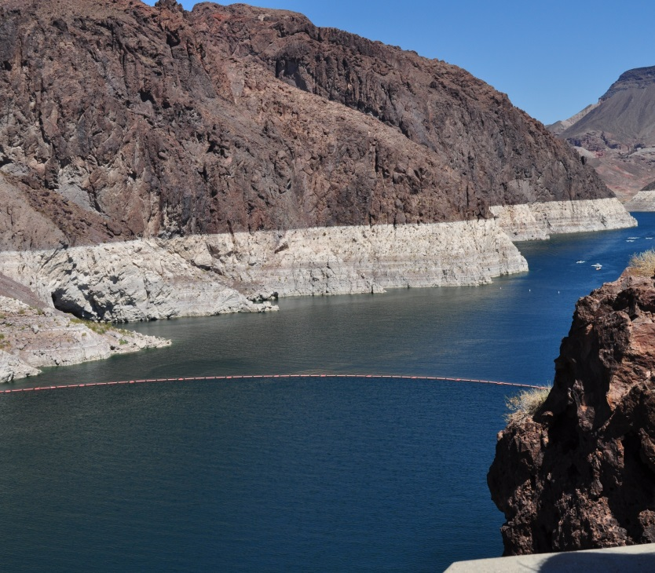
To date, there are several proposed solutions of how evaporation can be reduced in the big reservoirs, like a thin organic layer or actual cover sheets, but none was yet applied. And therefore the real impact on ecosystems is not precisely known but simply estimated. One sure problem would be the decrease in oxygen levels in the already not so rich in oxygen stagnant reservoir waters. Also considering the big surface to be potentially covered, the external factors like wind and temperature variation need to be taken in calculation.
Figure 3: Lake Mead(Source: Own picture)

Seawater up the rivers

The extensive usage of water for irrigation, along with the leaking channels and losses of water to evaporation which was discussed in the chapters above are contributing to another environmental problem. A decreased flow in a river is one of the causes for seawater intrusion in its delta, when that finds itself on a relatively extended low-flat area. With more and more dams holding back the water upstream there is an increasing number of saltwater intrusion cases.
According to the Southern Institute for Water Resources Research, in the dry season of 2013, the Mekong River flow deficit from 30% to 45% of water compared to the average level. The water level in upstream of the Mekong River is lower than the average level from 0.6 to 0.7 m. Therefore, saltwater intrusion will occur earlier and moves deeply into inland 40-50 km and even more. Salinity is higher than the same period in 2012 as well as the average of many years (T.Minh, 2013).

Dams trigger earthquakes?

Of increasing concern is the potential for dams in Southwest China to trigger earthquakes. Recent evidence has emerged that the devastating 7.9-magnitude Sichuan earthquake of May 2008, which killed an estimated 90,000 people, may have been caused by the Zipingpu Dam. It is well established that large dams can trigger earthquakes through what is called reservoir-induced seismicity. Scientists believe that there are more than 100 instances of reservoirs causing earthquakes around the world. According to geophysical hazards researcher Christian Klose of Columbia University, “The several hundred million tons of water piled behind the Zipingpu Dam put just the wrong stresses on the adjacent Beichuan fault” (World Watch, 2010).

Conclusion

Until quite recently I would have engaged fiercely into arguments defending the benefits dams bring to modern societies. And that is because I was seing only the top of the aisberg and not the full picture. And I am sure that most of the people out there do not think that dams could be bad in any way.
Now we know better and I can only hope that people learn from the past mistakes. Not every river is suitable for building dams and I am afraid the best sites are already taken anyway. And with wind and solar energy becoming more and more affordable it is simply no longer economically feasible to continue damaging rivers and the ecosystems connected to them. So instead of building news dams we should consider taking down those which are really working against us. The green energy status of many hydropower dams should be reconsidered and the flux of investments redirected towards something sustainable indeed. It is outrageous how at this crucial stage for climate change we have built dams with higher green house emissions than fossil fuel plants. Even if these emissions are to cease one day, it might no longer matter since it is going to be too late for a climate irreversabily changed.
Now that these new finding will be taken in consideration the world map for greenhouse emission has to change significantly. Countries which are claiming funds for new projects of “green” hydropower will have to prove first that their energy will really be green. Also the actual trade of carbon credits must be re-evaluated. Hydropower dams can no longer benefit from their so called status of “clean energy”, since emissions have been found at all the reservoirs, though not as high as in those in the sub-tropical region.
And in this paper only the major, controversial environmental impacts of dams were described and yet, I think enough argumets were provided to conclude that the policy regarding dams has to be rivisited and revised With lifetimes of under 40 years they are simply environmentaly non-sustainable.

Bibliography
Cernea, M. M., 2004. Social Impacts and Social Risks in Hydropower Programs. Beijing, China, s.n.
International Rivers, 2008. Dammed Rivers, Damned Lives. International Rivers.
Mohamed Elsawwaf, P. W. A. P. J. B., 2009. Evaporation estimates from Nasser Lake, Egypt., s.l.: Springer.
Network, I. R., n.d. International Rivers. [Online]
Available at: http://www.internationalrivers.org/files/attached-files/wwf3.4-warming_0.pdf
[Accessed 21 October 2013].
Pearce, F., 2006. When the Rivers Run Dry. Boston: Beacon Press.
T.Minh, 2013. http://www.monre.gov.vn. [Online]
Available at: http://www.monre.gov.vn/v35/default.aspx?tabid=675&CateID=59&ID=125722&Code=1XJJ125722
[Accessed 22 October 2013].
World Commission on Dams, 2000. Dams and Development: A New Framework for Decision-Making, s.l.: Earthscan Publications Ltd.
World Watch, 2010. Greenwashing hydropower. January/February.

